SOFTWARE REQUIREMENTS
SPECIFICATION
AI EAP Integration Accelerator Platform

Table Of Content  Section Heading | Page Number
1. Introduction | 3
1.1 Purpose | 3
1.2 Scope | 3
2. System Overview | 4
2.1 Platform Description | 4
2.2 Core Modules | 4
2.3 Role in Semiconductor Automation | 4
3. Functional Requirements | 5
3.1 Document Management Requirements | 5
3.2 AI Data Extraction Requirements | 6
3.3 Equipment-to-MES Mapping Requirements | 7
3.4 Code Generation Requirements | 8
3.5 Simulation and Testing Requirements | 8
3.6 Template Management Requirements | 9
3.7 User Access and Dashboard Requirements | 10
4. Non-Functional Requirements | 10
4.1 Performance Requirements | 10
4.2 Security Requirements | 10
4.3 Reliability Requirements | 10
4.4 Scalability Requirements | 10
4.5 Maintainability Requirements | 10
4.6 Compliance Requirements | 10
4.7 Usability Requirements | 11
5. Conclusion | 11

1. Introduction
1.1 Purpose
The purpose of this Software Requirements Specification (SRS) document is to define the functional and non-functional requirements for the AI EAP (Equipment Automation Program) Integration Accelerator platform designed for semiconductor manufacturing environments. This platform automates the traditionally manual process of semiconductor equipment integration with Manufacturing Execution Systems (MES) by leveraging artificial intelligence, standardized protocol processing, intelligent mapping, automated code generation, simulation, and reusable integration templates.
The document establishes a comprehensive technical foundation for stakeholders, software engineers, quality assurance teams, semiconductor equipment vendors, and integration specialists to ensure accurate implementation, validation, and maintenance of the platform.
1.2 Scope
The AI EAP Integration Accelerator platform provides an end-to-end enterprise solution for accelerating semiconductor tool integration by automating:
- Equipment technical document ingestion and analysis
- SECS/GEM protocol data extraction
- Status Variable (SV), Data Variable (DV), Event, and Alarm extraction
- Intelligent mapping of equipment parameters to MES structures
- Automated EAP driver and integration code generation
- Virtual simulation and testing of generated integrations
- Reusable template management for future deployments
The system supports semiconductor equipment categories includes but not limited to:
- Chemical Vapor Deposition (CVD)
- Etch Systems
- Lithography Tools
- CMP Equipment
- Metrology Systems

2. System Overview
2.1 Platform Description
The AI EAP Integration Accelerator is an enterprise-grade software platform that automates semiconductor equipment integration workflows using AI-driven analysis, standards-based communication models, and reusable software generation capabilities.
The platform transforms equipment manuals, protocol definitions, and vendor documentation into deployable MES integration assets by systematically processing technical inputs through six core operational modules.
2.2 Core Modules
2.2.1 Document Upload Module
Provides secure ingestion of semiconductor equipment manuals in PDF, DOCX, TXT, and related technical formats. The module validates file integrity, vendor metadata, and version information.
2.2.2 AI Extraction Module
Uses artificial intelligence to extract Status Variables (SV), Data Variables (DV), Collection Events (CEID), Alarm Definitions (ALID), communication structures, and equipment parameters.
2.2.3 Smart Mapping Module
Automatically maps extracted equipment signals to MES-compatible structures while providing confidence scoring, review workflows, and manual override capabilities.
2.2.4 Code Generation Module
Generates production-ready EAP drivers, communication handlers, configuration files, and integration logic in supported programming languages such as C# and .NET.
2.2.5 Simulation Dashboard Module
Provides virtual equipment behavior simulation, message validation, event testing, alarm testing, and MES response verification prior to production deployment.
2.2.6 Integration Templates Module
Maintains reusable templates for vendor-specific and tool-specific deployments, reducing repetitive engineering work.

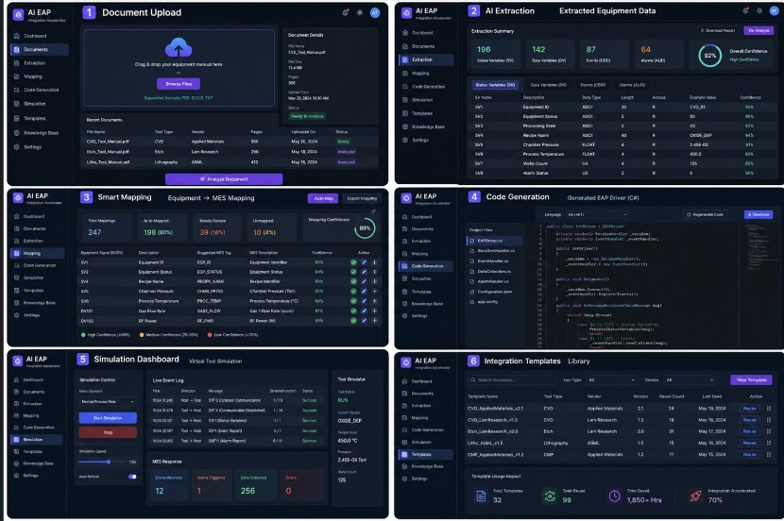
The above is the sample UI design.
2.3 Role in Semiconductor Automation
The platform serves as an accelerator for semiconductor equipment onboarding into fab automation systems by standardizing GEM/SECS integration, reducing deployment risks, improving MES compatibility, enhancing engineering productivity, and supporting future scalability across fabs.

3. Functional Requirements
3.1 Document Management Requirements
3.1.1 The system shall allow authorized users to upload semiconductor equipment technical documents in PDF, DOCX, and TXT formats.
3.1.2 The system shall validate uploaded documents for format compatibility, file integrity, and completeness prior to analysis.
3.1.3 The system shall extract and store metadata including file name, equipment type, vendor, document version, upload date, and page count.
3.1.4 The system shall maintain version-controlled storage of uploaded documents for traceability and audit purposes.
3.1.5 The system shall support drag-and-drop and manual file browsing mechanisms for document submission.
3.1.6 The system shall display document processing status including uploaded, analyzing, analyzed, and failed states.
3.1.7 The system shall securely store uploaded documents within enterprise-access-controlled repositories.
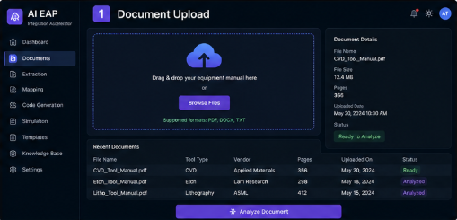
The above is the sample UI design.
3.2 AI Data Extraction Requirements
3.2.1 The system shall analyze uploaded technical manuals using AI models trained on semiconductor equipment documentation.
3.2.2 The system shall identify and extract SECS/GEM communication definitions including streams, functions, variables, alarms, and events.
3.2.3 The system shall classify extracted data into Status Variables (SV), Data Variables (DV), Collection Events (CEID), and Alarm IDs (ALID).
3.2.4 The system shall assign confidence scores to all extracted parameters based on AI model certainty.
3.2.5 The system shall allow users to review, approve, or modify extracted outputs before downstream processing.
3.2.6 The system shall generate downloadable extraction reports for engineering validation.
3.2.7 The system shall preserve source traceability linking extracted data back to original document sections.

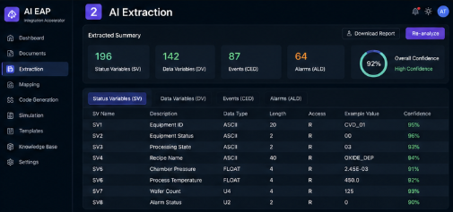
The above is the sample UI design.

3.3 Equipment-to-MES Mapping Requirements
3.3.1 The system shall automatically map extracted equipment variables to MES-compatible tag structures.
3.3.2 The system shall provide confidence scoring for each mapping recommendation.
3.3.3 The system shall support manual override, correction, and approval of AI-generated mappings.
3.3.4 The system shall identify unmapped variables requiring engineering review.
3.3.5 The system shall support export of approved mappings for integration deployment.
3.3.6 The system shall preserve mapping templates for reuse across similar equipment categories.
3.3.7 The system shall validate mapping completeness prior to code generation.
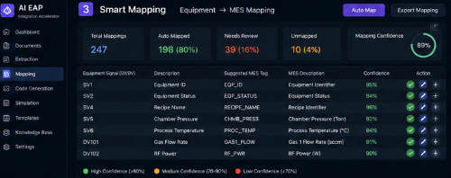

The above is the sample UI design.

3.4 Code Generation Requirements
3.4.1 The system shall automatically generate production-grade EAP driver code based on approved mappings.
3.4.2 The system shall generate communication handlers for SECS/GEM and HSMS interactions.
3.4.3 The system shall generate configuration files, event handlers, alarm processors, and deployment-ready project structures.
3.4.4 The system shall support regeneration of code following mapping or extraction modifications.
3.4.5 The system shall ensure generated code adheres to SEMI E30, E37, and GEM-300 compliance standards where applicable.
3.4.6 The system shall support code download for enterprise deployment.
3.4.7 The system shall maintain code generation history for version comparison and auditing.
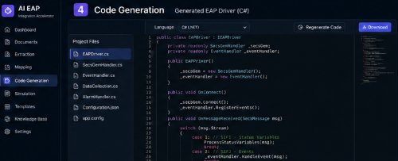
The above is the sample UI design.

3.5 Simulation and Testing Requirements
3.5.1 The system shall provide a virtual simulation environment for generated EAP integrations.
3.5.2 The system shall simulate host-tool communication sessions including status requests, event reports, and alarms.
3.5.3 The system shall validate generated drivers against expected MES communication workflows.
3.5.4 The system shall provide real-time event logging for all simulation activities.
3.5.5 The system shall support configurable test scenarios including normal flow, fault injection, and recovery validation.
3.5.6 The system shall track simulation metrics including data collection counts, alarm triggers, and communication errors.
3.5.7 The system shall support engineering approval prior to production deployment.
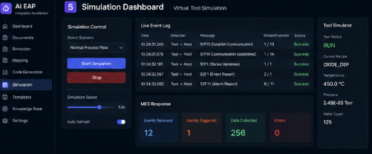
The above is the sample UI design.

3.6 Template Management Requirements
3.6.1 The system shall maintain a centralized repository of reusable integration templates.
3.6.2 The system shall categorize templates by equipment type, vendor, protocol version, and deployment history.
3.6.3 The system shall allow authorized users to create, update, and reuse templates.
3.6.4 The system shall track template reuse metrics and engineering time savings.
3.6.5 The system shall support search and filtering of templates by tool type and vendor.
3.6.6 The system shall enforce template version control and governance policies.
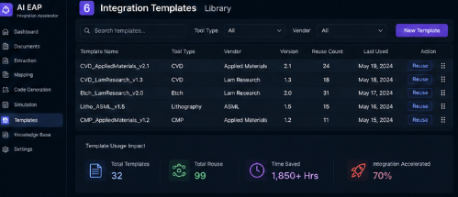
The above is the sample UI design.

3.7 User Access and Dashboard Requirements
3.7.1 The system shall provide role-based access control for administrators, engineers, QA personnel, and viewers.
3.7.2 The system shall provide dashboard visibility into all workflow stages including upload, extraction, mapping, code generation, and simulation.
3.7.3 The system shall support project lifecycle tracking for each integration initiative.
3.7.4 The system shall maintain complete audit trails for user actions and approvals.
3.7.5 The system shall support secure authentication and session management.
3.7.6 The system shall provide configurable notifications for workflow status changes.

4. Non-Functional Requirements
4.1 Performance Requirements
4.1.1 The system shall process standard equipment manuals within acceptable enterprise-defined SLA timelines.
4.1.2 The system shall support concurrent multi-user document analysis without significant performance degradation.
4.1.3 The system shall generate code and simulation environments within operationally efficient time frames.
4.2 Security Requirements
4.2.1 The system shall enforce secure authentication and role-based authorization.
4.2.2 The system shall encrypt sensitive documents, mappings, and generate code at rest and in transit.
4.2.3 The system shall maintain compliance with enterprise cybersecurity policies.
4.2.4 The system shall log all security-related events for auditing.
4.3 Reliability Requirements
4.3.1 The system shall maintain high operational availability for enterprise deployment.
4.3.2 The system shall provide fault recovery mechanisms for interrupted workflows.
4.3.3 The system shall preserve data integrity across all modules.
4.4 Scalability Requirements
4.4.1 The system shall support expansion across multiple fabs, vendors, and equipment classes.
4.4.2 The system shall scale horizontally to accommodate increasing document and integration workloads.
4.5 Maintainability Requirements
4.5.1 The system shall support modular software architecture for future enhancements.
4.5.2 The system shall allow independent updates to AI models, protocol libraries, and templates.
4.5.3 The system shall maintain detailed system logs for troubleshooting.
4.6 Compliance Requirements
4.6.1 The system shall align with SEMI E30 (GEM), E37 (HSMS), and applicable GEM-300 standards.
4.6.2 The system shall support auditability for regulatory and customer compliance validation.
4.7 Usability Requirements
4.7.1 The system shall provide an intuitive enterprise dashboard interface.
4.7.2 The system shall minimize engineering learning curves through workflow-guided interfaces.
4.7.3 The system shall support visual confidence indicators and review checkpoints.
5. Conclusion
The AI EAP Integration Accelerator platform is designed to modernize semiconductor equipment integration through intelligent automation, standards compliance, reusable engineering assets, and deployment acceleration. By combining AI extraction, mapping automation, code generation, and simulation into a unified enterprise workflow, the platform significantly reduces integration complexity, improves deployment speed, and enhances semiconductor manufacturing operational excellence.

